

Industrial Training Final Report (CSF47112) Semester I Session 2020/2021
Pangkalan Bekalan Kemaman Sdn. Bhd

NURAIN SYUHADA BINTI MOHAMMAD AMIRUDDIN (074579)
Bachelor of Computer Science (Software Development)
Faculty of Informatics and Computing

Industrial Training Final Report (CSF47112)
Semester I Session 2025/2026
Pangkalan Bekalan Kemaman Sdn. Bhd

NURAIN SYUHADA BINTI MOHAMMAD AMIRUDDIN

BACHELOR OF COMPUTER SCIENCE
(SOFTWARE DEVELOPMENT) WITH HONOURS
FACULTY OF INFORMATICS AND COMPUTING
UNIVERSITI SULTAN ZAINAL ABIDIN

CONFIRMATION

This is to confirm that:
The research conducted and the writing of this report was under my supervision.

Industry Supervisor;

Name: ……………………………………. Date: ………………………………………

Company’s official stamp

Academic Supervisor;

Name: ……………………………………. Date: ………………………………………

Company’s official stamp

DECLARATION

I hereby declare that this report is based on my original work except for quotations and citations, which have been duly acknowledged. I also declare that it has not been previously or concurrently submitted for any other degree at Universiti Sultan Zainal Abidin (UniSZA) or other institutions.

Name: NURAIN SYUHADA BINTI MOHAMMAD AMIRUDDIN
Matric Number: 074579
Date:

ACKNOWLEDGEMENT

In the name of Allah, the Most Gracious and the Most Merciful. Alhamdulillah, all praise is due to Allah SWT for His blessings and guidance, which enabled me to successfully complete my industrial training report.

First and foremost, I would like to express my sincere gratitude to my academic industrial training advisor (PALI), Pn. Fatimah Binti Ghazali, for her continuous guidance, valuable advice, and constructive feedback throughout the industrial training period. I would also like to express my deepest appreciation to my industrial training supervisor, Pn. Normah Binti Ibrahim @ Ghazali, for her guidance, support, and patience in supervising me during my internship at Pangkalan Bekalan Kemaman Sdn. Bhd. (PBKSB), a subsidiary of EPIC Berhad. My sincere thanks also go to all the staff of PBKSB for their cooperation, valuable knowledge, and for providing me with the opportunity to gain exposure to a real working environment and daily operations, which greatly enriched my learning experience. I would also like to thank the Faculty of Informatics and Computing, Universiti Sultan Zainal Abidin (UniSZA) for their continuous academic support and guidance throughout this industrial training.

Lastly, I am deeply grateful to my family and friends for their constant encouragement, understanding, and moral support throughout this journey. May Allah SWT reward everyone who has contributed directly or indirectly to the successful completion of this report.

Thank you.

ABSTRACT

This report documents my industrial training experience at Pangkalan Bekalan Kemaman Sdn. Bhd. (PBKSB), a subsidiary of EPIC Berhad (Eastern Pacific Industrial Corporation Berhad). The primary objectives of this internship were to understand daily operational workflows, support ongoing projects, and analyze operational challenges and potential improvements within the organization.

Throughout the training period, I was involved in activities related to port services, supply chain operations, maintenance coordination, and safety system monitoring. Key findings from this experience revealed inefficiencies in equipment utilization and limitations in existing data tracking practices. Based on these observations, several actionable recommendations are proposed, including optimizing crane scheduling, enhancing digital inventory tracking systems, and strengthening preventive maintenance procedures.

These proposed improvements aim to reduce operational downtime, lower maintenance costs, and enhance overall service reliability. The insights and recommendations presented in this report are expected to contribute to EPIC Berhad’s continuous operational improvement and long-term organizational growth.

TABLE OF CONTENT

CONFIRMATION i
DECLARATION ii
ACKNOWLEDGEMENT iii
ABSTRACT iv
TABLE OF CONTENT v
LIST OF TABLES vii
LIST OF FIGURES viii
CHAPTER 1 1
INTRODUCTION 1
1.1 Introduction to the Company 1
1
1.2 Industrial Training Job Scope 3
1.3 Objectives 4
1.4 Report Structure 5
CHAPTER 2 6
PROJECTS & ASSIGNMENTS 6
2.1 Project 1: Developing 6
2.1.1 Project Introduction 6
2.1.2 Project Methodology and Design 6
2.1.3 Software & Hardware Used 6
2.1.4 Project Implementation & Results 6
2.2 Project 2: Developing 7
2.2.1 Project Introduction 7
2.2.2 Project Methodology and Design 7
2.2.3 Software & Hardware Used 7
2.2.4 Project Implementation & Results 7
CHAPTER 3 7
DAILY TASK / ASSIGNMENT 7
3.1 Introduction 7
3.2.1 Develop …. programming 7
3.2.2 Self-Learning about …. 7
3.2.3 Designing ….? 7
3.2 Daily Task / Assignment 7
3.3 Conclusion 7
CHAPTER 4 8
CONCLUSION 8
4.1 New Knowledge / Skill Gained During the Training 8
4.2 Limitations 8
4.3 Constraints and Suggestions 8
4.4 Challenges and Opportunities 8
4.5 Summary 8
REFERENCES 8

LIST OF TABLES

FIGURE | TITLE | PAGE
1.1 | First table in chapter 1 | 10
1.2 | Second table in chapter 1 | 15
2.1 | First table in chapter 2 | 20
2.2 | Second table in chapter 2 | 22

LIST OF FIGURES

FIGURE | TITLE | PAGE
1.1 | First figure in chapter 1 | 10
1.2 | Second figure in chapter 1 | 15
2.1 | First figure in chapter 2 | 20
2.2 | Second figure in chapter 2 | 22

CHAPTER 1

INTRODUCTION

Introduction to the Company

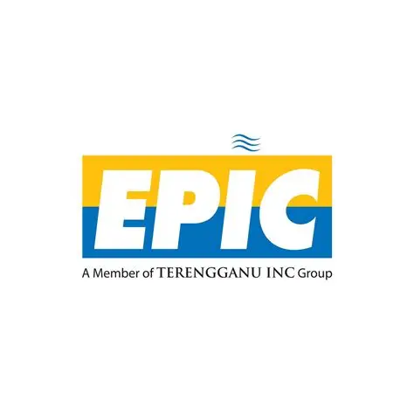
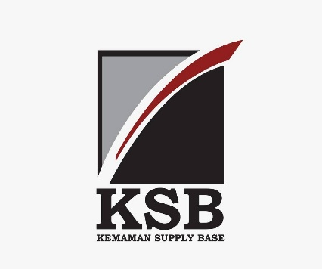

Figure 1.1: Epic Berhad and PBKSB Logo

Eastern Pacific Industrial Corporation Berhad (EPIC) was incorporated on 17 January 1981 and operates as an investment holding company with subsidiaries involved in oil and gas, port, marine, and renewable energy sectors.

One of EPIC’s key subsidiaries is Pangkalan Bekalan Kemaman Sdn. Bhd. (PBKSB), which owns and operates the Kemaman Supply Base (KSB). The supply base covers approximately 200 hectares, with an additional 60 hectares reserved for future expansion. KSB operates under the Petroleum Supply Base scheme, which provides special tax and customs incentives, allowing deferred duties for equipment entering and leaving the base. More than 200 support service companies operate within KSB, offering services such as fabrication, inspection, logistics, and maintenance to support offshore oil and gas activities.

EPIC’s core business clusters include supply base and support services, oil and gas together with renewable energy, as well as port and marine services. In 2024, EPIC generated approximately RM214 million (53%) from supply base and support services, RM99 million (25%) from oil, gas, and renewable energy, and RM91 million (22%) from port and marine services, reflecting the strategic importance of KSB within the group’s overall operations.

In upstream services, EPIC owns EPIC Oilfield Services Sdn. Bhd. (EOS), which specializes in threading of premium API tubular connections and has expanded into inspection, rental, waste management, and machine shop services. EPIC has also invested in renewable energy through its subsidiary, EPIC Solar, as part of its long-term sustainability strategy.

EPIC actively engages in strategic collaborations to enhance operational capabilities. In 2023, the company signed several memoranda of understanding with industry partners focusing on capacity building, technical support, and infrastructure development. In collaboration with PETRONAS, EPIC plans to establish a centralised warehouse at Kemaman to improve logistics efficiency and operational integration. Additionally, EPIC is developing a Green Ship Recycling Facility at Kemaman Port, targeted for completion by 2026 in compliance with international standards.

In January 2024, EPIC reported an improved profit outlook, targeting RM14.9 million due to increased demand for port operations at Kemaman and the introduction of new business activities. These developments highlight EPIC’s commitment to expanding its capabilities and strengthening its role in Malaysia’s oil and gas infrastructure.

This report focuses on my industrial training experience at Kemaman Supply Base (KSB) under Pangkalan Bekalan Kemaman Sdn. Bhd., examining operational practices, identifying key challenges, and proposing feasible, data-driven improvements based on real working exposure. Figures 1.2 below shows one of products from Pangkalan Bekalan Kemaman Sdn. Bhd (PBKSB):
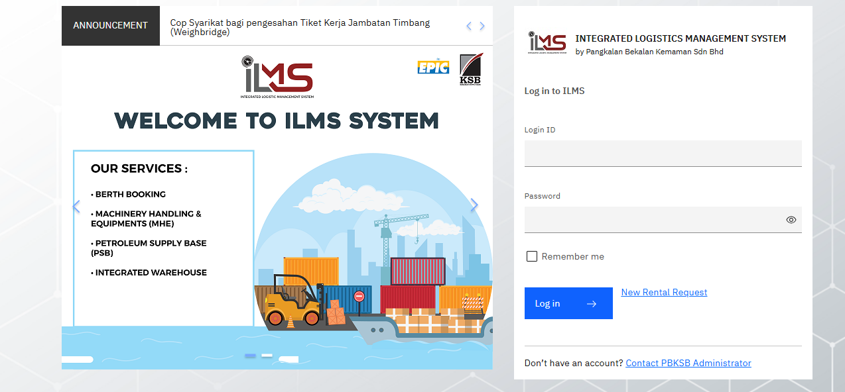

Figure 1.2: Integrated Logistic Management System (ILMS)
CHAPTER 1

Industrial Training Job Scope

- KTSB System Development (PHP/MySQL)
- Participated in the development of the KTSB (Kuala Terengganu Support Base) system using PHP and MySQL.
- Worked collaboratively with other interns under the guidance and supervision of IT staff throughout the system development process.
- Attended meetings related to the KTSB system and recorded meeting notes to understand system requirements, workflows, and improvement needs.
- Assisted in implementing system functions based on user and operational requirements.
- Conducted manual system testing to verify system functionality, accuracy, and reliability.
- Identified system issues and documented test cases, test results, and findings for improvement.
- Prepared system documentation, including manual testing documentation and a user manual, to support system usage and future maintenance.

- Centralized Purchase Requisition (PR) System
- Received exposure to the planning and initial concept of a Centralized Purchase Requisition (PR) System for EPIC Oil & Gas Sdn. Bhd..
- Gained understanding of the system objectives, scope, and proposed functionalities through discussions with IT staff.
- Although system development had not yet commenced during the industrial training period, the exposure provided insight into system planning and upcoming digital initiatives within the organization.

CHAPTER 1

Objectives

The objectives of the industrial training are as follows:
- To expose students to a real industrial working environment before graduation, particularly in the field of information technology and system development.
- To enhance students’ understanding of system development processes, including system planning, implementation, testing, and documentation, through hands-on involvement in real projects.
- To develop technical skills in web-based system development using PHP and MySQL through participation in the KTSB system development.
- To improve problem-solving, analytical thinking, and teamwork skills by collaborating with IT staff and other interns in system development activities.
- To provide students with practical experience in manual system testing and system documentation, including the preparation of user manuals.
- To prepare students for future professional roles by increasing awareness of organizational system requirements and upcoming digital initiatives, such as the Centralized Purchase Requisition (PR) System.

Report Structure

This industrial training report is structured into four chapters, each focusing on different aspects of the training experience.

Chapter 1 presents an introduction to the organization, including the company background, industrial training job scope, training objectives, and the structure of the report.

Chapter 2 describes the projects and assignments undertaken during the industrial training period. This chapter details the system development and technical projects, including methodology, implementation, results, and their impact on the organization.

Chapter 3 discusses the daily tasks and assignments performed throughout the training period, highlighting routine activities, system support tasks, and hands-on exposure gained during the internship.

Chapter 4 concludes the report by summarizing the knowledge and skills acquired, limitations encountered, constraints and suggestions, as well as challenges and opportunities experienced during the industrial training.

CHAPTER 2

PROJECTS & ASSIGNMENTS

2.1 Project 1: Developing

2.1.1 Project Introduction

2.1.2 Project Methodology and Design

2.1.3 Software & Hardware Used

2.1.4 Project Implementation & Results

2.1.4.1 Login Page

2.1.4.2 … Page

2.1.4.3 … Page

2.1.4.4 … Page

2.2 Project 2: Developing

2.2.1 Project Introduction

2.2.2 Project Methodology and Design

2.2.3 Software & Hardware Used

2.2.4 Project Implementation & Results

2.2.4.1 Login Page

2.2.4.2 … Page

2.2.4.3 … Page

2.2.4.4 … Page

CHAPTER 3

DAILY TASK / ASSIGNMENT

3.1 Introduction

3.2.1 Develop …. programming

3.2.2 Self-Learning about ….

3.2.3 Designing ….?

3.2 Daily Task / Assignment

3.3 Conclusion

CHAPTER 4

CONCLUSION

4.1 New Knowledge / Skill Gained During the Training

4.2 Limitations

4.3 Constraints and Suggestions

4.4 Challenges and Opportunities

4.5 Summary

REFERENCES

